UMRCC Fish and Wildlife Tech Section Meeting Agenda

September 10-12, 2019

**Meeting Location** –Wyalusing State Park, 13081 State Park Lane, Bagley, WI  53801 or for the GPS crowd:  42.978150, -91.114009

**Wyalusing SP Website:** <https://dnr.wi.gov/topic/parks/name/wyalusing/>

**\*\*\* For those folks staying in the bunk rooms please remember to bring along your own sleeping bag/blankets, pillows, and towels. Apologies to our USFWS Partners, I was unaware of your lodging policies when I reserved this location-Jordan**

**We Need Headcount for meals so please pre-register with Patrick Short:** [Patrick.Short@wisconsin.gov](mailto:Patrick.Short@wisconsin.gov)

**If you have any questions pertaining to wildlife presentations please contact  
Brenda Kelly:** [Brenda.Kelly@wisconsing.gov](mailto:Brenda.Kelly@wisconsing.gov)

**Registration $55**

**Tuesday, September 10**

10:00 – 12:30 Arrival/Check in and Registration, Lunch on your own. Check in also available after 5:30

1:00 – 1:30 Welcome and Logistics

1:30 – 5:00 Presentations

5:30 – 6:30 Fish Fry (Dining Hall)

6:30- 10:00 Social around campfire

**Wednesday, September 11**

7:30 – 8:30 Breakfast at Group Camp

**Joint Fish and Wildlife session

8:30 - 9:00 Presentation

9:00 - 9:30 Presentation

9:30 - 10:00 Presentation

10:00 - 10:30 Break

10:30 - 11:00 Presentation

11:00 - 12:00 Presentation

12:00 -1:00 Lunch (Sandwiches-make your own, fixings provided)

1:00 – 5:00 Field Trip - McGregor HREP

5:00 - 6:00 Supper (On your own in PDC) Map of local restaurants provided

**Thursday, September 12**

7:30 – 8:30 Breakfast

8:30 – 10:30 Separate Fish and Wildlife Meetings

10:30 Adjourn, clean up, check out, and lunch on your own.

**Tuesday, September 10, 2019 – Joint Meeting**

Joint meeting of the UMRCC Fish Tech and Wildlife Tech was convened at 1:00 by Jeff Janvrin (Wisconsin Dept. of Natural Resources) and Mike Flaspohler (MO Dept. of Conservation), respectively.

Albany Island Fisheries Response Monitoring - *Royce Bowman, Iowa DNR* – Royce presented preliminary results of post project sampling at Albany Island where a chevron was constructed and bank stabilization work was done. Channel catfish, flathead catfish, smallmouth bass and bluegill all had increases in CPUE at the project location when compared to pre project conditions. These increases were substantially higher than observed CPUE for these species at a nearby control. Largemouth bass also had increased CPUE, but the increase were similar to what was observed at the control site.

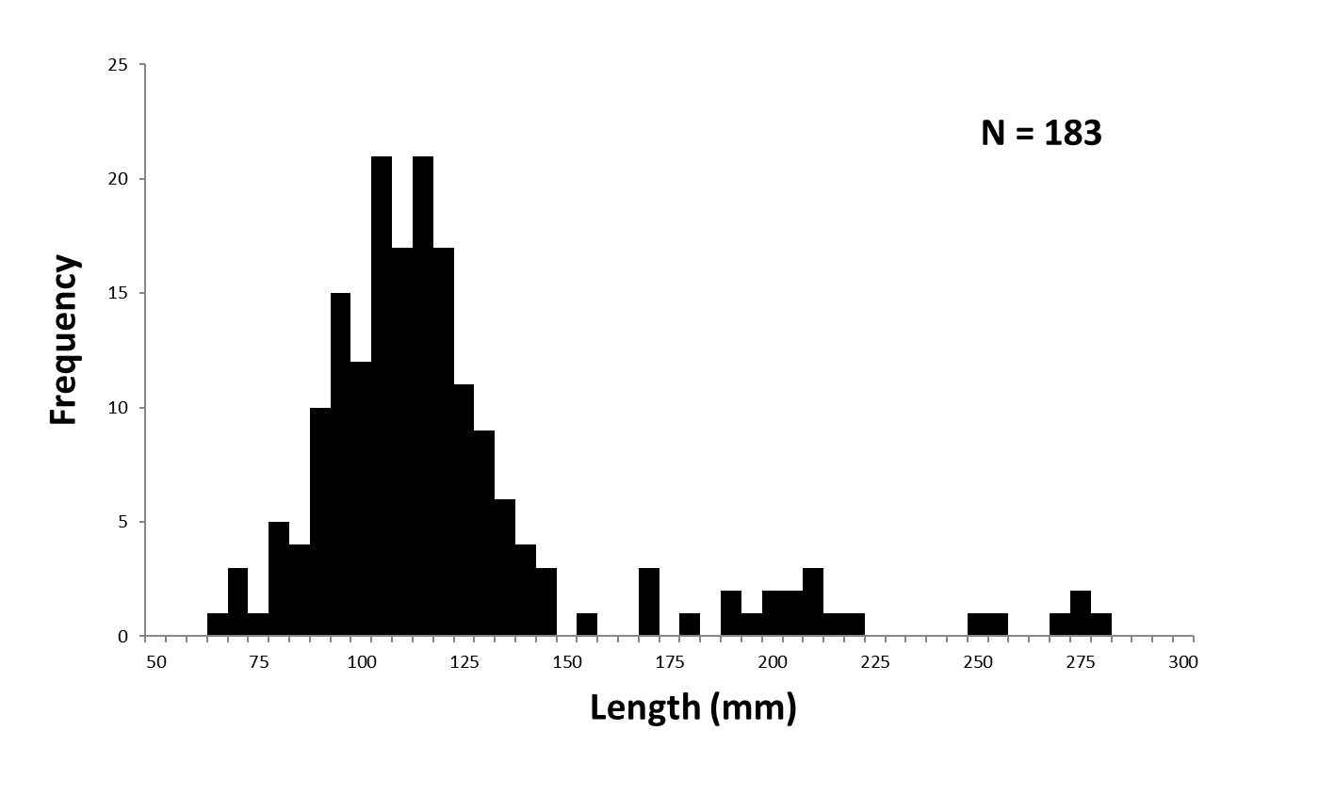

Grass Pickerel at Green Island, Pool 13 – *Royce Bowman, Iowa DNR* – Fisheries sampling within Green Island found many grass pickerel during daytime electro shocking runs (CPUE averaged 23/hour). Total catch was 183 individuals. Most were caught in dense mats of coontail. Grass pickerel in Iowa are classified as a T&E species.

Emerging Issue? Bowfishing Tournaments - *Nick Schlesser, Minnesota DNR* – ***See Attachment A for a summary of presentation, discussion by the tech sections and action item forwarded to the Exec. Board.***

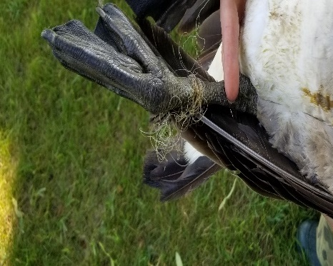Goose Banding in WI – *Sam Sauber, Wisconsin DNR* – WI DNR’s annual Mississippi River goose banding utilizes the assistance of many agencies and public to accomplish. Efforts are made to go beyond the waterfowl hunting crowd for assistance. Families and the youth are specifically invited to participate. This provides youth with the opportunity to hold geese and learn about how banding is done and why it is important. They sometimes see first-hand some of the threats human actions pose to waterbirds (i.e. fishing line and hooks). Some parents that participated as youth are now bringing their kids to help.

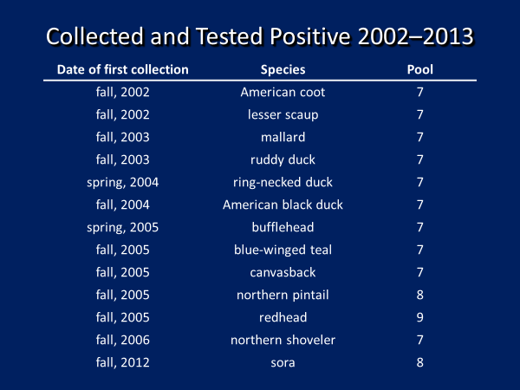Mortality of Scaup and other Waterbirds Caused by Trematodiasis on the Upper Mississippi River – Analyses of Long-term Datasets – *Steve Winter, USFWS Upper Miss. Refuge* – Trematodiasis was first documented in 2002 on Pool 7 of the UMR. Most subsequent mortality events have been in Pools 7 and 8. Consumption of just a few infected snails by a waterbird can result in death within 48-72 hours. Over the years, tracking of reported mortalities of known and unknown causes was in 20 different datasets. These datasets were not structured/organized in a manner that allowed for sorting, filtering and the use of pivot tables or analysis.

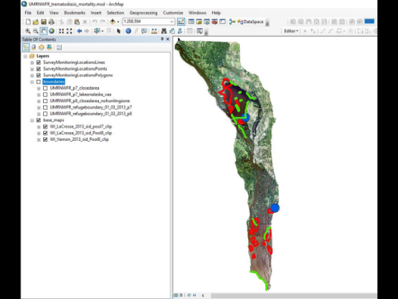

USGS/USFWS Science Support Partnership (SSP) and Quick Response Partnership (QRP) grants were submitted to develop a waterbird mortality MS Excel database, ArcGIS geodatabase and parasitology and diagnostic database. The databases and final reports will be housed in the USFWS ServCat.

Reports from the existing 20 databases were screened for questionable records. These included records from holiday or weekend dates, those reported by the public only, and records of events that occurred more than once at the same location during the same week or same day. Resulting database now includes 645 records representing unique combinations of survey/monitoring locations and dates. Seventy-three unique areas in the original databases were reclassified into 38 unique names plus one classification for “ambiguous” where the original specific area was difficult or impossible to deduce. The comprehensive database contains many of the fields in the original files plus additional/new fields to enhance utility.

Preliminary results obtained from the consolidated database:

* 14 species representing the Family Anatidae
* 2 species representing the Family Rallidae
* 26,988 dead and 2,725 sick American coots
* 11,306 dead and 598 sick lesser scaup
* 275 dead and 5 sick blue-winged teal
* 232 dead and 22 sick ring-necked ducks

Next steps include: basic and descriptive analysis of the database, complete final report, finish parasitology and diagnostic database, publish papers and archive all databases/mortality report and published papers on ServCat.

Do You Know Where the Stateline Is? – *Jeff Janvrin, Wisconsin DNR* – The location of the state lines within the Mississippi River floodplain are portrayed in several different locations depending on the source (i.e., Google, Bing, USGS Topos, State coverages, etc.). USGS maps are often mistakenly used as an authoritive source, but are only a general reference of the state line and in general cannot be used for legal purposes. Topo maps are “The official boundary of federal, state, local and tribal governments as reported/certified to the U.S. Census Bureau.” Therefore, it is the state’s responsibility to certify the accuracy of any state boundary representation.

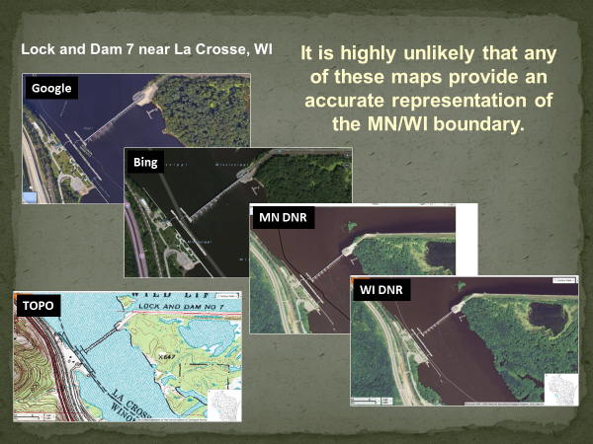

With today’s technology, accurate accessible maps of state boundaries are needed for: law enforcement, permitting, liability, litigation, emergency response, closure for families, etc. The position of the state line is based upon PLS surveys at the time of statehood and instructions within the state’s constitution, for example, both MN and WI constitutions reference the boundary as the main channel of the Mississippi River. In all cases, the first state’s surveys take precedence when there is a discrepancy. For UMRCC states, this would mean going back to 1818 when Illinois first became a state, yet the accuracy and availability of maps this old are not up to today’s standards. But collectively, historic maps and survey records can be pieced together to identify a data informed location that is reproducible.

Several different methods can be potentially used to identify a mutually agreed upon location of the state line based on historic maps of the River, the original PLS survey meander lines and other documents. A comparison of the state line coverages from several sources shows that for the majority of the River most show it’s location in very similar locations. However, there are areas where multiple maps differ significantly. These appear to be primarily near locks and dams, the impounded portion of pools and areas where dredging activities to maintain the 9-foot channel have altered floodplain features. ArcGIS and other software can be used to create an accurate and mutually agreed upon location of the state line based on PLS surveys and georeferenced historic maps, LIDAR and air photos.

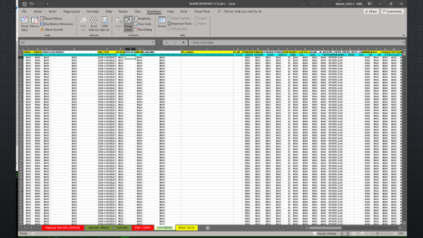

Development of an Electronic Data Collection Program for WDNR Miss. River Fish Team or…Death by Excel!!!– *Keith Weaver, Wisconsin DNR* – Wisconsin has developed an electronic data capture Excel spreadsheet as a temporary in-the-field data entry platform while work progresses on a data entry program for the River that will integrate directly to the statewide fisheries database. The excel spreadsheet contains all fields present in the Wisconsin statewide database (107 columns!), yet during field entry only about 20 columns are used, with many filled out just once a day (i.e. crew, pool, equipment, WSEL, flow, etc.). This application also includes some additional features such as real time length frequency of target species.

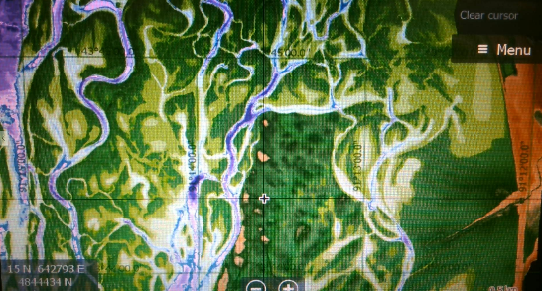Use of Customized Base Maps on Lowrance Depth Finders – *Troy Clemment, Wisconsin DNR -*  WDNR has been using Lowrance depth finders to plot waypoints of sample locations, obtain GPS coordinates of gear deployment and to create and/or display tracks of electro shocking runs. Recently, recorded tracks of runs have been exported to ArcGIS. Another feature of these units that has been useful is the creation of custom depth maps either through Lowrance’s social map application or analysis in Bio Base software. Both approaches allow staff to create depth maps for portions of the River that do not have LTRM bathymetric coverage. The Lowrance depth finders also allow for importation of custom base maps. WDNR has created custom air photos to be used as a base map and created bathymetric maps from LTRM Topobathy Layer. One lesson learned from the creation of these custom maps is that the datum must be WGS84 prior to transforming into files appropriate for the Lowrance software to use.

Wisconsin Chronic Wasting Disease Update – *Terry Shaurette, Wisconsin DNR* – Currently WI has 56 CWD affected counties (26 with wild positives). This reflects an increasing prevalence and geographic spread. WI has baiting and feeding bans and Transportation restrictions to minimize spread. In 2018 sampling year 17,325 samples were taken, of which 1,061 were positive. Projecting 21,000 samples in 2019 with district wide surveillance in Northern District. Five townships will have mandatory in-person registration for opening weekend as part of a mandatory sampling area. This mandatory in-person registration was recommended by the Chippewa Valley CWD Advisory Team. Cooperators in sampling effort are taxidermists who are paid $11 per sample to collect lymph nodes. This focuses more on older bucks. Bars, spots shops and bait shops may also collect heads and are reimbursed $9.50 per sample. Self service kiosks are also being used: 24/7 sampling option but requires frequent checking and more data corrections. Adopt-a-kiosk allows for clubs or individuals to get involved to help check the kiosks and are given recognition for their participation.

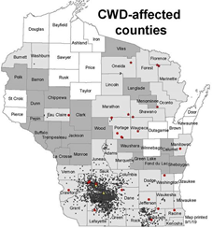

Survivability of Planted Containerized Tree Stock During and Post Inundation-Spring 2019 – *Chis Dojutrek, USACE Rock Island* – The spring and summer of 2019 had prolonged flooding on several sites that had containerized tree stock planted in the Rock Island District. Growing season high water (duration and depth) is one factor that can affect survivability of tree plantings. Multiple site visits were made to Pleasant Creek and Maquoketa DMMP site. Between March 13 and 14, the Mississippi River jumped roughly 3 feet overnight at Bellevue, IA, Lock and Dam 12, 9.59 feet (“normal pool”) to 12.27 ft, respectively. The first site visit was when the stage was 16.77 at LD12 on March 28 which inundated the site by 4-5 feet of water. Trees were underwater and dormant. The second visit was on May 9 (LD12 stage 17.37). Trees were in budding in 2-4 feet of water at Pleasant Creek and in 0-2 feet of water at Maquoketa DMMP. The third visit was Aug. 1 (LD12 stage 13.42). Trees were out of water at both locations and vegetation growing.

Post flood site analysis found survivability varied by species. All river birch made it. Buds were dormant underwater and didn’t leaf out until water receded to about 4 feet, exposing buds to sunlight. Two surviving American Sycamore were found. No surviving Eastern Cottonwood. Observations of post-inundation survivability included:

* 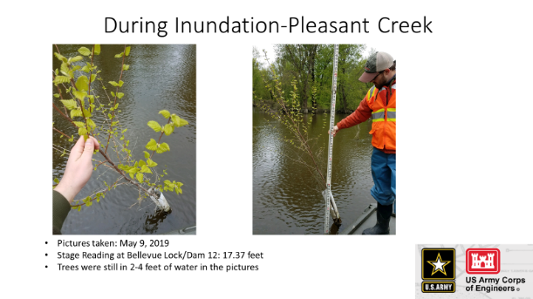As water recedes, it is important to be timely to upright trees.
* Roots of river birch were half exposed to air and half to soil, but still moist and growing, although they were still leafing out and growing.
* Trees were stood back upright and staked to grow straight.

Linking LTRM Vegetation Data with Bioenergetics Needs of Waterfowl to Inform Wildlife Habitat management – *Kirsten Schmidt, UW Stevens Point* – Wild celery is an important food resource on the Mississippi River for canvasbacks. Wild celery winter buds provide 3.2 kcal/g. Canvasback’s daily caloric requirement is 400 kcal/day, which is about 125g of winter buds. The goal of the study was to estimate the kcal of wild celery in Pools 4, 8 and 13 to:

* Determine if LTRM protocols can be used to reliably predict wild celery presence/abundance;
* Determine if canvasbacks are consuming winter buds at a greater rate in closed areas compared to open areas;
* Identify and estimate waterfowl food biomass (tubers, rhizomes, seeds, SAV and invertebrates).

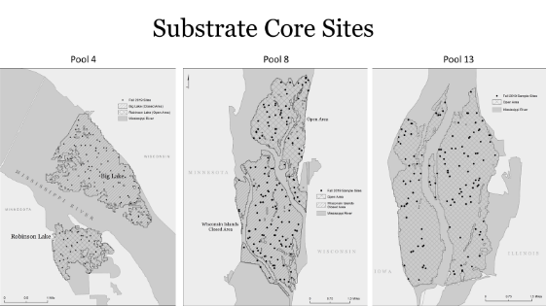

Samples were collected in the summer using LTRM rake protocols and substrate cores in the fall/spring in areas open and closed to hunting. Spring core samples were conducted before waterfowl arrived and started feeding. A 50X50 meter grid was overlaid onto potential sample sites where water depths were <3m and the nodes were randomly selected for sampling. All LTRM rake sites where wild celery was present were sampled with substrate core. 50% of sites with no LTRM celery were sampled with the sediment core.

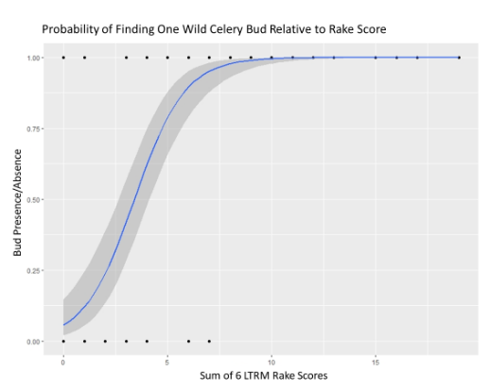

Logistic regression shows the probability of encountering at least one wild celery bud (y-axis) relative to the cumulative rake score at each site (x-axis). The pattern is promising and there are some key observations. Keep in mind this is only pool 8 data. There is a very small likelihood of encountering ANY buds when the cumulative rake score is 0. There is about a 50% chance of encountering at least one wild celery bud when cumulative rake score is between 3 and 4. But by the time cumulative rake scores are 7 the probability spikes to 90% and any score higher than that you are almost certainly going to find at least one wild celery bud.

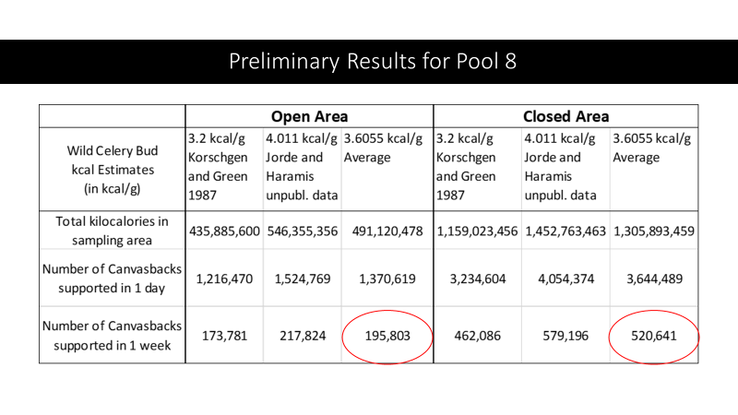

**Wednesday, September 11, 2019 – Joint Meeting**

Huron Island Aquatic Planting (Huron Island HREP) – *Bre Popkin, USACE Rock Island* –

History of the Fish Tech Section – *Kevin Hansen, Iowa DNR* – This was a more in-depth presentation of what he provided at the UMRCC 75th Annual meeting. See the proceedings of the 75th annual meeting for transcript of the talk or forthcoming UMRCC 75-year History publication for more information.

History of the Wildlife Tech Section – *Mike Griffin, Iowa DNR, Retired* – This was a more in-depth presentation of what he provided at the UMRCC 75th Annual meeting. See the proceedings of the 75th annual meeting for transcript of the talk or forthcoming UMRCC 75-year History publication for more information.

Wisconsin R3 – *John Motoviloff, Wisconsin DNR* –

Paddlefish Overwintering Locations and Spring Movements in the St. Croix and Mississippi Rivers – *Joel Stiras, Minnesota DNR* – Minnesota has been using acoustic transmitters to track paddlefish in the St. Croix River and Pools 2-4 of the Mississippi River since 2013. Spring destination tracking was variable with regards to upstream or downstream movements from overwintering areas. For example, in 2016-2017about half the fish that overwintered in Pepin stayed in Pepin, 2 traveled upstream and 4 traveled into the Chippewa River to varying degrees. Tracking has revealed several overwintering locations and documented that LD2 is a major barrier to upstream passage by paddlefish although one of fish that passed LD2 went at least 102 miles upstream with much of that movement in the Minnesota River. Acoustic array has detected paddlefish from as far south as Pool 16 in lake Pepin.

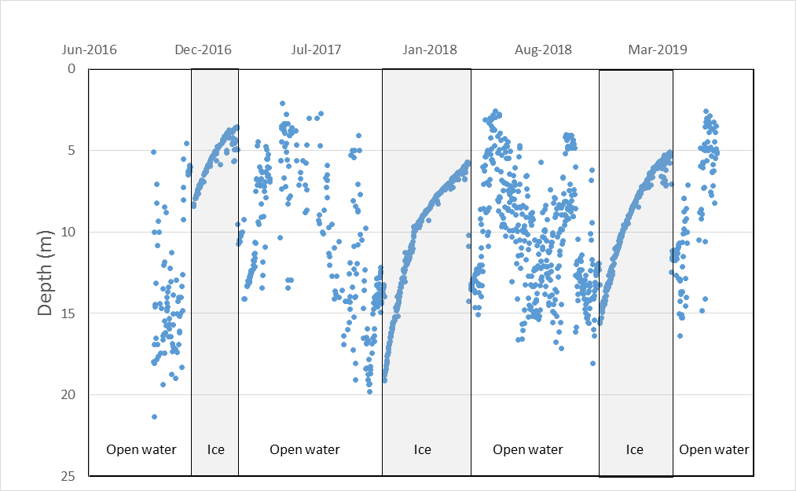Out of 21 paddlefish that have 2016/2017 and 2017/2018 winter data, over 71% chose the same winter location, indicating some overwintering fidelity. Only locations that were chosen back to back are in Lake Pepin and the Afton Pool of the St. Croix. It appears that depth may be an important attribute for winter site selection. All paddlefish with depth transmitters (10) show similar patterns of depth use regardless of wintering location. Fish start at a deeper depth at ice-up and rise at a fairly predicable rate over the winter until ice-out.

**Afternoon** - Joint Field Trip to McGregor Lake HREP project area and Effigy Mounds National Historic Site.

**Thursday, September 12, 2019 – Joint Meeting**

Freshwater Mussel Ecology and Identification – *Lisie Kitchel, Wisconsin DNR* – Twenty-four of the 50 freshwater mussel species in Wisconsin are endangered, threatened or of special concern. Many of the remaining ones are also at risk. Mussels are long lived, require a vertebrate host to complete life cycle and since the host is so significant, they have developed unique abilities to attract and attach to host species (usually a fish). Biologically/ecologically, mussels are important for many reasons: ecological services by providing food for fish and wildlife, habitat and food for benthos, removal of pollutants, bio monitors and an important component of stream processes.

**Thursday, September 12, 2019 – Fish Tech Meeting**

Fish Tech Bowfishing Tournaments – Discussion – *All* – ***See Attachment A for a summary of presentation, discussion by the tech sections and action item forwarded to the Exec. Board.***

Fish Passage on the Mississippi River – Discussion of UMRBA request for input on issue – *All* – The UMRBA has contacted the UMRCC for input on the interest of Mississippi River fisheries biologists to pursue fish passage if NESP receives funding in the coming years. Fish passage at selected locations underwent feasibility studies several years ago when funding was appropriated for NESP projects. Travis Moore mentioned that quite a bit of planning had been done for passage at LD22. Discussion focused on how passage for native fish would match with the barrier recommendations presented by the invasive carp group. Consensus of membership present was that native fish passage is through locks and dams on the UMR continues to be an important factor in the distribution of species and an important consideration in developing future ecosystem restoration projects. Specifically, providing opportunities for passage of native fish species at locks and dams below LD19 should be considered. Consideration of fish passage projects above LD19 requires more in depth consideration by state partners to ensure that improvements in fish passage do not facilitate increased spread of Asian carps. Review of any previously conducted feasibility reports is needed due to recent changes in discharge, need to consider data from more recent studies, use of new sorting technology and to possibly design in a way that would allow for testing of invasive carp barriers within passage structure (adaptive management with control).

Discussion also included the need for consideration of other projects that where not included for consideration when NESP developed the initial list of projects. MN specifically recommended seeking guidance on how to propose a project that would now be possible given the closure of the St. Anthony Falls LD. For example, would rapids restoration below the dam be considered as a potential new project? All were in agreement that the list of NESP projects with potential fishery features should be reviewed and perhaps updated based on more recent lessons learned and data that has been collected and analyzed. If a NESP letter is prepared by the Exec Board, the tech section membership present recommended that language be included to propose a review of previously proposed projects and inclusion of new projects for consideration.

**UMRCC Fish Tech POC’s are to develop draft language on support for NESP fish passage for use in a UMRCC letter when requested.** While the membership present was supportive of potentially implementing passage at dams below LD19, this is not an endorsement of plans developed in past NESP funding. A review of past NESP passage planning is needed as part of the NESP reboot.

Border Water Regs Update – *All* – The changes in MN and WI regs will both be going forward next year. Upper Pool 9 will match with IA.

Fish Compendium – *All* – The compendium is nearing completion. All members have been asked to do the following:

* Look over images in the document to see if they have better ones for some of the poorer images. Specific examples were diver photos and habitat photos. Please send any images you have to Nick.
* Need to know how many printed copies each state needs and which universities or other libraries folks want a copy sent to. Once again, send list to Nick. Cost for printed versions is estimated to be $30 - $35. UMRCC will cover the costs.

Topic for future meeting: The inadequacy of existing HEP/AHAG models was mentioned more than once during the meeting, and it was pointed out this topic has come up at other partnership meetings. Recommendation was to discuss course of action at future meeting.

**Thursday, September 12, 2019 – Wildlife Tech Meeting**

Wildlife Tech Bowfishing Tournaments – Discussion – *All* – ***See Attachment A for a summary of presentation, discussion by the tech sections and action item forwarded to the Exec. Board.***

Other minutes to be added by Mike Flaspohler.

*Note: Both tech sections participated in the presentation and discussion on Tuesday afternoon and each met separately for further subject matter expert discussion on Thurs. morning. These notes are from the Tues. joint discussion and the individual fish and wildlife technical section discussions on Thursday.*

**Fish Tech Action Item**: Dan Dieterman and Travis Moore will draft a letter for fish tech review. Upon Fish Tech approval, letter will be submitted to the Exec. Board with request to send out to the UMRCC fish chiefs.

* Letter will focus on our need for data to support continuation of recreational activity. For example, lack of population and life history information on many of the fish species targeted by bow fishing.
* Use this opportunity to obtain information about these species given the harvest technique is lethal, which provides an opportunity to get information before the fish are disposed of.
* Recommendation for each state to document number, size and locations of bow fishing tournaments within their waters.
* Recommendation for each state to provide personnel to attend 1 – 2 bow fishing tournaments within their respective states to obtain harvest information by species (length and weight) and aging structures from selected species (i.e. buffalo, suckers).
* A sampling protocol would be developed by the Fish Tech section over the winter for implementation beginning in summer 2020.
* Since many of these species are also commercial species, funding may be available within each state to investigate potential impacts on commercial harvest.

**Background:**

Nick Schlesser (MN DNR) presented observations MN DNR made at 2 different bowfishing events in 2019. Both events spanned several pools on the Mississippi River. Their investigations were in part due to a growing number of complaints about the use of mudboats, airboats and other watercraft capable of operating in shallow, vegetated areas. Specifically mentioned were letters to the MN DNR commissioner from residents on Weaver Bottoms in Pool 5 and a resolution from the MN Izaak Walton League.

This issue extends beyond just bow fishing tournaments (which typically occur during the night time). Duck hunting, trapping and ice fishing also use similar watercraft. However, the discussion at the UMRCC joint Fish and Wildlife Tech Sections meeting focused on bow fishing.

In MN Statute rough fish is defined as “…carp, buffalo, sucker sheepshead, bowfin, burbot, cisco, gar, goldeye and bullhead, except for any fish species listed as endangered, threatened, or of special concern…” Many of these species are specifically targeted in bow fishing tournaments. Within MN, black buffalo and blue sucker are listed as state special concern. River redhorse, black redhorse and greater redhorse are species of greatest conservation need (SGCN) in MN. It is unknown how well bow anglers can identify these species of concern prior to harvest.

Bowfishing tournaments that target rough fish do not require a MN tournament permit. Therefore, MN databases do not include any specific information that would allow for tracking of trends in these types of tournaments. However, observations are these tournaments are increasing in frequency and size. It is believed these same advances in shallow water navigation have also resulted in an increased recreational bow fishing on the Mississippi River.

Nick provided summaries of the harvest during BAA and a smaller event, the Paul Bunyan Classic (9 registered teams). The Bowfishing Association of America (BAA) world championship was based in Winona and angling activities covered 140 miles from Red Wing to Iowa border (6 pools). BAA had 104 teams with participants from 12+ states. BAA tried to be proactive on noise/disturbance complaints and was very willing to cooperate with MN DNR data collection.

Pre-tournament fishing was reported in many areas. Observations indicate that pre-fishing/scouting even occurred within areas identified as areas to avoid due to either sensitive resources or proximity of residences. These “red zones” were developed by the Refuge and BAA provided to tournament participants.

As would be expected, the harvest results were different for the two events with regards to number of fish. There were differences in the predominantly harvested species between the two tournaments. Noteworthy is that 2 silver carp were taken during pre-fishing for the BAA tournament.

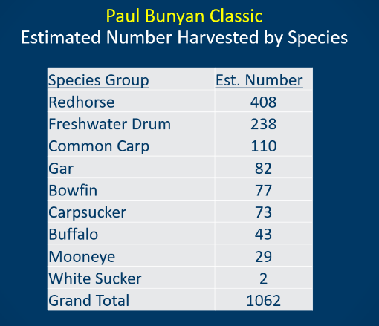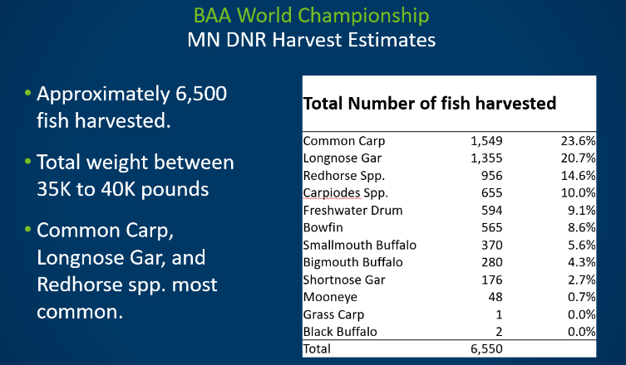

Nick provided a comparison of the bowfishing harvest vs. MN commercial fishing reports. These two tournaments harvested significantly more bowfin, gar and redhorse than annual average harvest by MN commercial harvest. Three redhorse species are listed as SGCN and one is a SC species in MN.

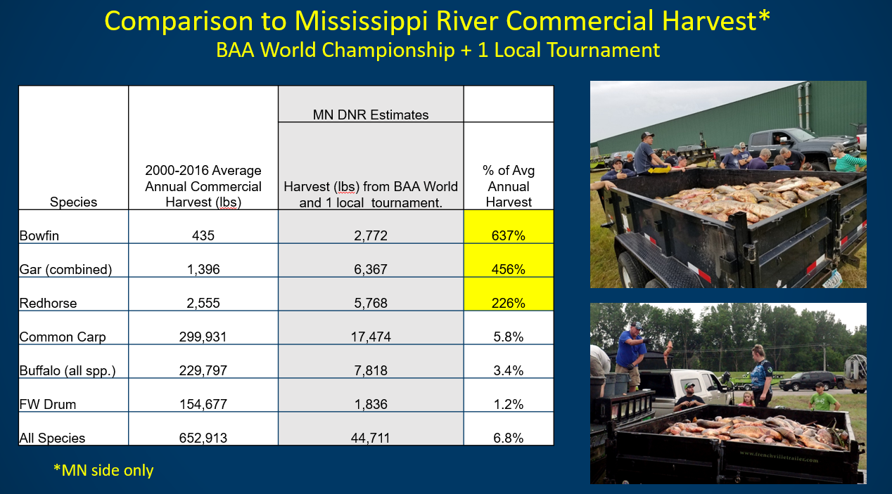

**Joint Fish and Wildlife Tech Discussion:**

Nick said it is likely MN will move toward permitting of bowfishing tournaments. Group consensus was that step 1 was to track the number and size of events within all states. Most states have no information on rough fish tournaments on the River nor many regulations that would apply.

MN conveyed that a proposed buffalo study was not funded because of it’s rough fish status, and therefore, was not considered a game fish. A comment was made that if funds were not available through sportfish funding sources, perhaps commercial harvest funds could be used since bowfishing and commercial harvest targets many of the same species.

Question was asked if any states had harvested fish donated to a food pantry vs. just being land spread or otherwise disposed of. No one was aware of any bowfishing tournaments that processed fish for food pantries. It was noted that the condition of the fish did not appear to be suitable for consumption due to number of hours the bow harvested fish spent in the summer heat prior to and after the weigh in.

Following social aspects of bowfishing, the group was asked to focus on any known or potential biological impacts of bowfishing. No members could recall any studies specific to bowfishing biological impacts. Several potential biological impacts that applied to bowfishing and/or shallow water navigation were identified:

Potential biological impacts:

* Disturbance of resting wildlife/waterfowl
* Disturbance of fish spawning areas
* Access to fish overwintering sites
* Potential harvest impacts on native species
* Destruction of vegetation
* Incidental take of rails, wood duck broods
* Colonial Nesters (black terns)
* Mussel spawning (both harvest of some species that are known hosts for rare or threatened mussels, but also mussel spawning in shallow water environments).
* Buffalo displacement from OW sites.

Consensus of combined fish and wildlife tech sections was to continue discussion of topic during Thurs. separate section meetings. Focus was to be continued discussion on potential biological impacts.

**Fish Tech Bowfishing Discussion – Thurs. Sept. 12:**

Nick said the tournaments offer a good opportunity to get biological data on species we have limited data on, specially structure and biological data that would require sacrificing a fish we sampled. He recommended a letter be sent to state agencies with suggestions on the type of data we need: pressure info, elevate awareness of issue and conflicts, how does river harvest differ from inland harvest, what is their capacity to do anything (regulatory, sampling/monitoring, etc.).

Travis Moore pointed out that bow fishing is not an issue in Missouri sections of the River. This may be due to limited water clarity or other reasons.

There was discussion on what we can do now.

* each state attending 1-2 tournaments to get basic biological data
* set up protocol/procedures to get good consistent data
* use lessons learned from MN DNR involvement at BAA tournament
* Michelle Marron offered to pull together commercial data summary by state and pool for species that are commonly harvested by bow anglers.
* Static camera creel technique was mentioned to get a better handle on the amount of recreational bow fishing that is occurring

The rational for bow tournaments to participate with data collection is that we need the information to provide support for their activities. Without data, the decision will be solely based on societal considerations.

Dan Dieterman and Travis Moore “volunteered” to prepare a draft letter to state fish chiefs requesting support for better tracking of bow fishing tournaments and collection of data on species harvested at the tournaments.

**Wildlife Tech Bowfishing Discussion – Thurs. Sept. 12:**

To be added by Mike Flaspohler.

Bowfishing Association of America World Championship and Minnesota Paul Bunyan Classic

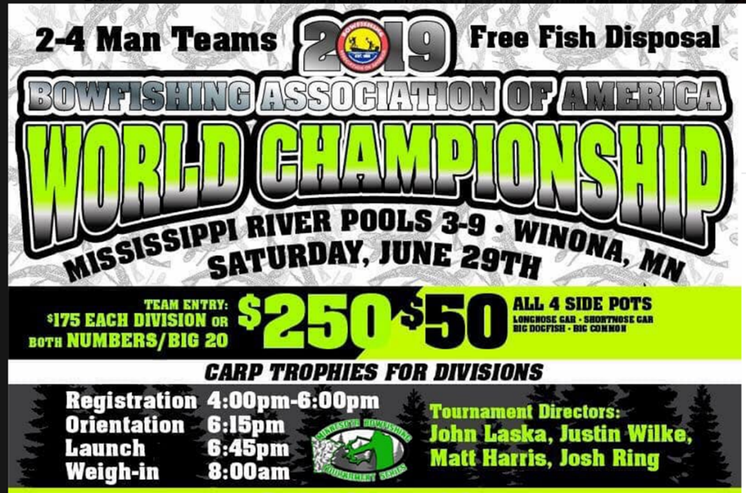

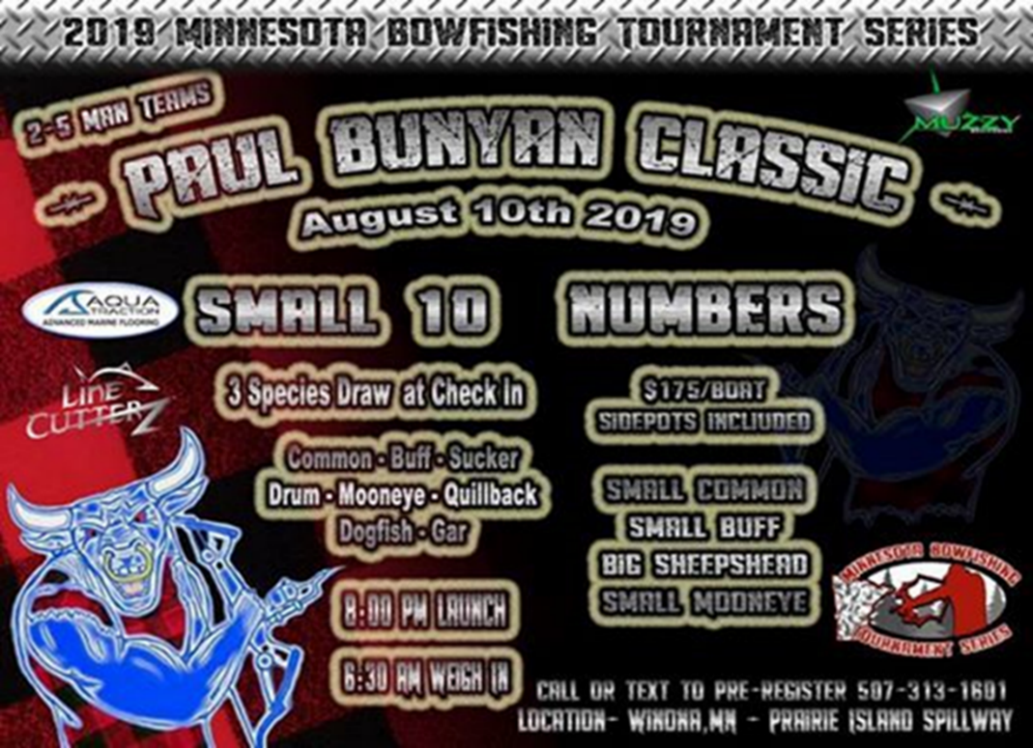

Commercial fish harvest (lbs.) from 2005-2015 compared to estimated BBA World Championship harvest (lbs.) and one local tournament.





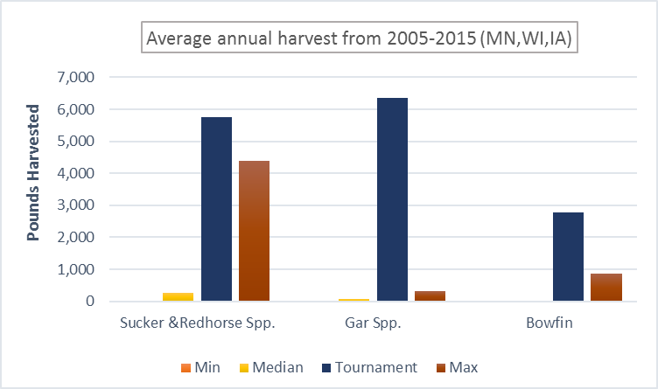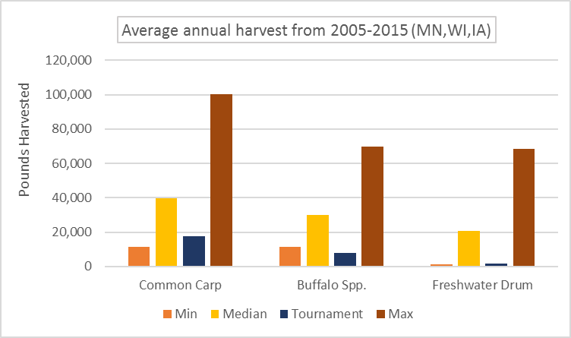





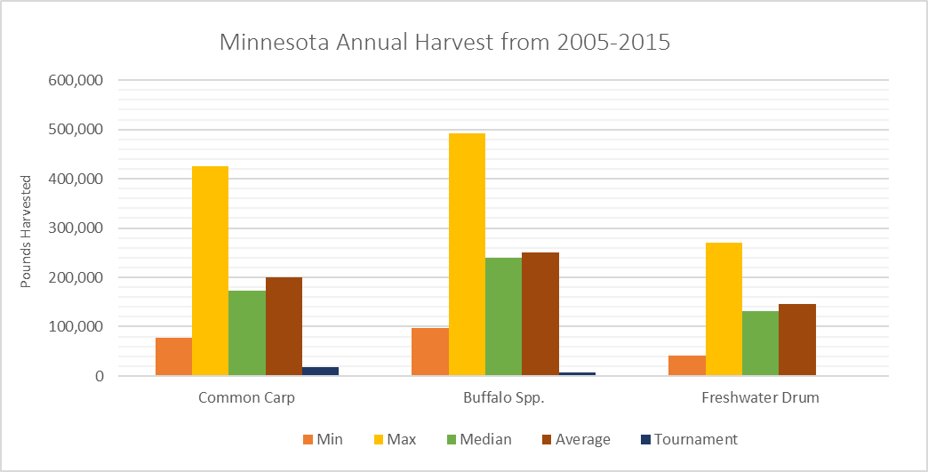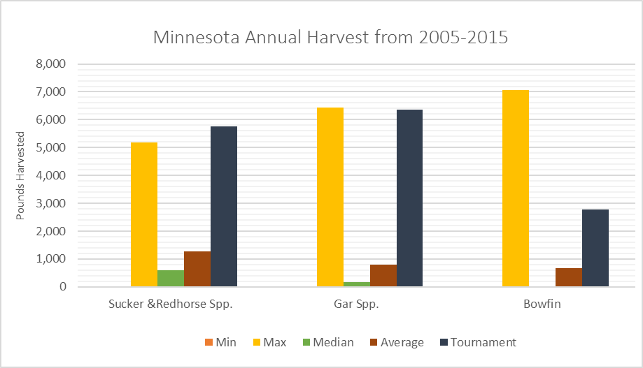



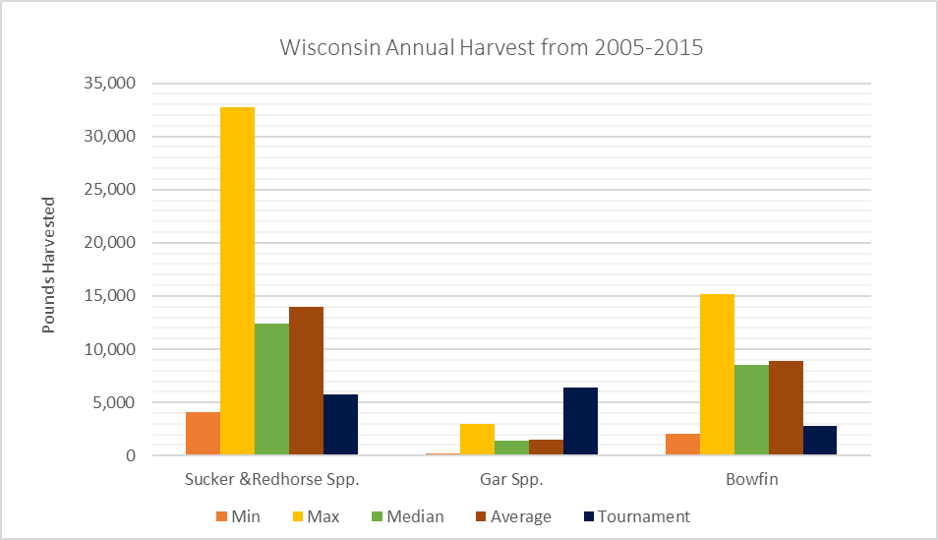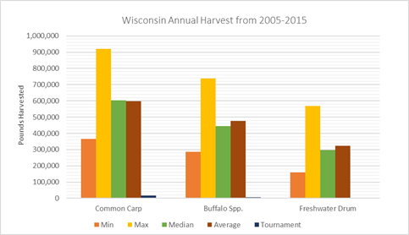

BBA estimated total harvest by MN DNR.



Paul Bunyan Classic estimated total harvest by MN DNR.



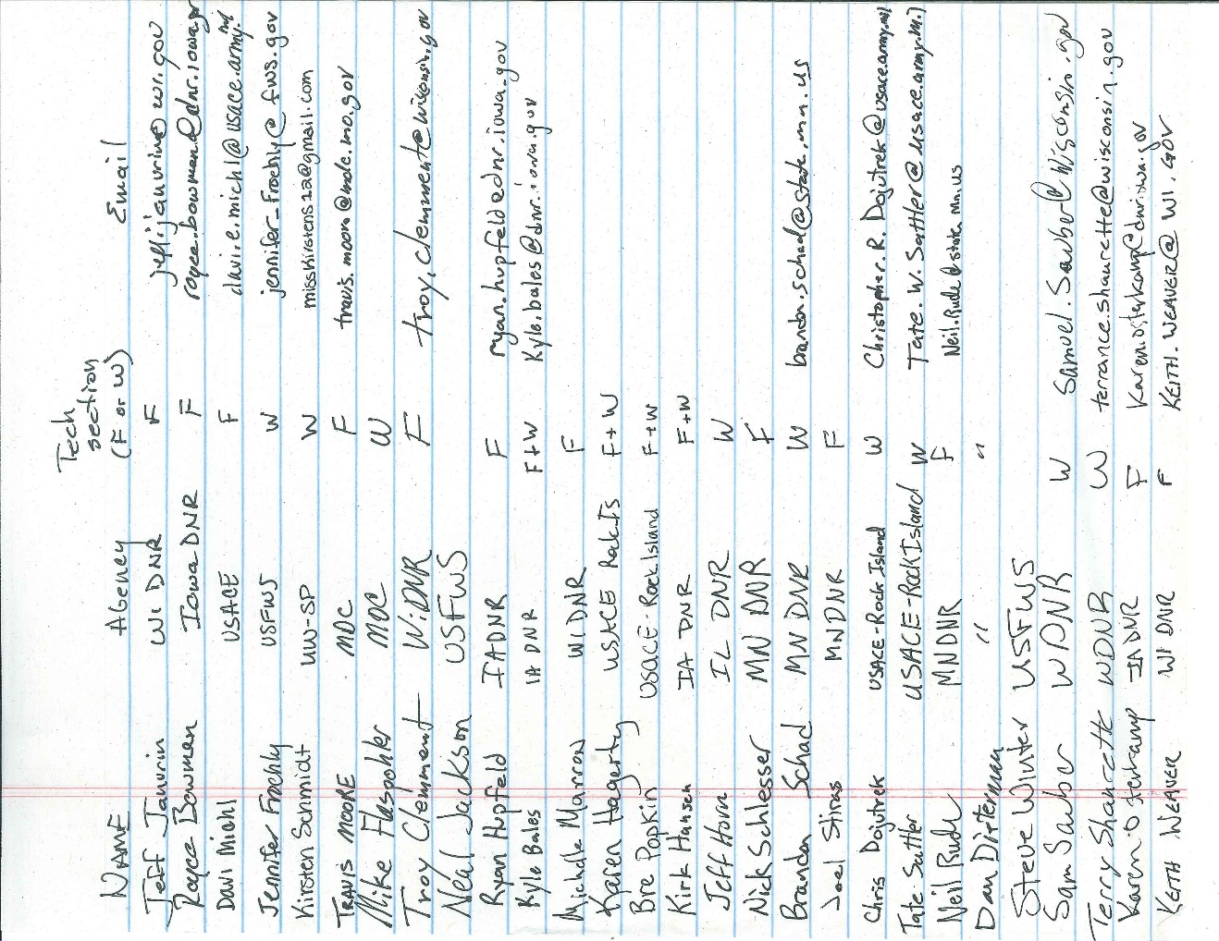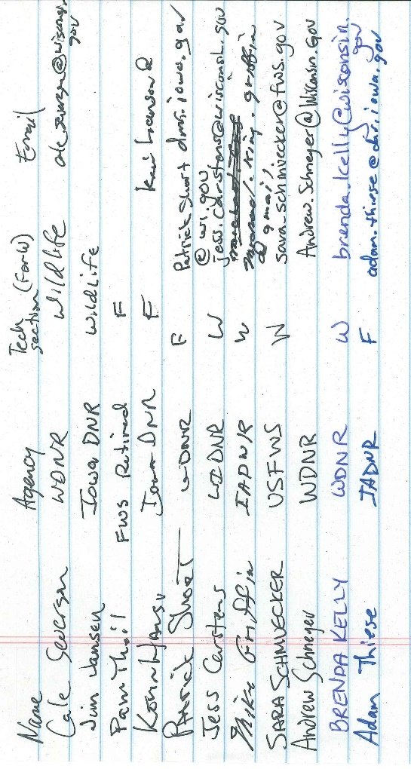

**ELECTRONIC AGENCY UPDATES FALL 2019**

**WILDLIFE TECH SECTION**

**WYALUSING STATE PARK, WI**

**Illinois Department of Natural Resources Agency Update**

UMRCC fall wildlife technical section – Wyalusing, WI

Illinois has a new governor and a budget. IDNR has returned to regular operations. We have a new Department head, Colleen Callahan, who has an agricultural background. We are currently without a Division chief and seeking candidates. We’ve also had a few retirements and filled those district positions. Scott Schaeffer and Kevin Oller retired (both had districts with counties along the Mississippi). Beth Weber and Walt Pumfrey were hired to fill those districts. I’ve included the new district map and will send it to Neal Jackson to update the UMRCC directory.

Like most of the Midwest, Illinois had an extremely wet spring and summer in 2019 that delayed or prevented planting across most of the state. Corn and soybean production are predicted to be down 17% and 25% respectively. We have the most fallow fields I’ve ever seen in my lifetime. That should benefit wildlife this fall and winter. The wet spring also effected nesting. Turkey broods are fewer and later than usual. Doves and wood ducks also seem to be down this year.

Our Chronic Wasting Disease management program remains our division’s top priority. The only change for the upcoming season is the use of some thermal riflescopes. This will make our sharpshooting efforts more efficient. The number of our CWD positives in FY 19 was up a fair amount from the previous year, but we did not have it show up in any new counties.

Illinois increased the daily limit on Canada geese during the regular waterfowl season from 2 to 3. Our early goose season limit remains at 5. As part of the Illinois DNR process to establish waterfowl hunting regulations for 2021-2025 seasons, Wildlife will hold a series of open houses in various places at the end of September into October.

**Iowa Report**

**Wildlife Technical Section**

**Fall 2019**

**HREP Construction:**

Conway Lake (Pool 9): construction contract awarded.  Construction scheduled to begin in 2020.

Harper's Slough (Pool 9): site visit to assess damages to islands and determine next steps scheduled for September.

Pool 12 Overwintering: construction of rock closing structure at Menominee Slough is scheduled for 2019.  Tree planting at Stone Lake and Kehough Slough to be conducted in subsequent years.

Beaver Island (Pool 14):  construction is ongoing.

Huron Island (Pool 18): rock protection and log structures installed and awaiting final surveys.  Trees, shrubs, and aquatic vegetation to be planted in 2019.

**HREP Planning:**

McGregor Lake (Pool 10): Feasibility report nearing completion.

Lower Pool 10:  Working on draft feasibility report.

Lower Pool 13:  Kick-off meeting held in May.  Working on draft feasibility report.

Green Island (Pool 13):  Fact sheet approved by MVD. Kick-off meeting to be scheduled in Oct-Nov.

Steamboat Island (Pool 14)  Working on draft feasibility report.

**CWD:**

In 2014 the first wild deer tested positive for CWD.   Iowa now has a total of 46 positive wild deer statewide.  Forty one of them are in counties bordering the river (34 Allamakee, 6 Clayton, 1 Dubuque).   The other 5 positives are in south central Iowa (Wayne County) located along the Missouri border.   We are trying to slow the spread through education and reducing deer numbers in counties with positives.  Tissue sample collection will be ramping up as deer seasons progress through the fall/winter.

**EHD:**

Iowa is experiencing EHD outbreaks across much of the state in late summer/early fall 2019.  As of mid-September, over 1,200 mortalities have been reported from at least 37 counties. The majority of cases are in south central Iowa, but there are a few cases reported from most Mississippi River counties as well.  This looks to be the 2nd worst year (2012 worst) for EHD in Iowa based on reported mortalities.

**Furbearers:**

Bobcat--We expanded the “open to hunting/trapping” zone northward to include 12 additional counties for the 2018-19 season.  Along the Mississippi we currently allow trapping from Jackson County to the southern border of Iowa. We implemented an increase in the bag limit from 1/furharvester to 3/furharvester across the southern three tiers of counties.

**Teal Season/Waterfowl:**

Iowa is using the maximum allowable days for the September teal season: Sep. 1 – 16.  At listening sessions near the Mississippi, most duck hunters are opposed to the season.  Major to record flooding occurred across much of the state in 2019. Resulting impacts to habitat are apparent this year, while long-term effects are yet to be determined.  Areas along the Mississippi continue to see declines in the forest resource from prolonged flooding.

**Staffing and Leadership:**

The Governor appointed a new DNR Director on June 26.  Kayla Lyon began her Director duties on July 8, serving as the eight Director for the agency and the first female Director.  The Deputy Director just retired, so another leadership position will soon be filled. Fish and Wildlife Trust Fund bureaus (Fisheries, Wildlife, Law Enforcement) have been steadily filling vacant positions during the past year, including the DNR’s first wildlife veterinarian.  DNR wildlife biologist Terry Haindfield (Allamakee and Clayton counties along the Miss) also just retired. This position will be filled immediately. There are rumors of increased chances that the sales tax based conservation funding will finally be put into action (sales tax increased) during the 2020 legislative session.  Iowa voters approved this measure in 2010, but no tax increase has been approved so funding has not been triggered.

**Missouri Update to UMRCC Fall Tech**

**Wyalusing State Park, WI**

**2019**

UMRR/HREP

The Mississippi River was in major flood stage from March through July of 2019 with many levees being overtopped and/or breached resulting in substantial damage to infrastructure up and down the river. Tree plantings associated with the Shanks HREP, Ameren Mitigation, and other bottomland plantings may be in serious jeopardy from the prolonged flood event. We spent about three weeks pumping water off tree plantings at Shanks. We saw some signs of life but will have to wait to see how many trees will survive and green up next spring.

Waterfowl

Shanks staff trapped and banded over 300 wood ducks using rocket nets over bait. No local efforts were made along the Upper river to band Canada geese. There were numerous broods of small wood ducks being observed along the river in August indicating what appeared to be a pretty good re-nesting effort.

In what certainly is not a normal year, I had a fried send me this photo of black-bellied whistling ducks just north of Hannibal. These birds spent about a week coming and going to his pond in mid-June. We also had confirmed nesting in SE Missouri for the second time in three years!

A flock of seagulls standing next to a body of water

Description generated with very high confidence

CWD

CWD monitoring and planning efforts are underway for the fall hunting seasons that start with archery September 15th. We will be conducting mandatory sampling in all 29 CWD Management Zone counties November 16th and 17th (opening weekend) of our firearms deer season. In past years this has provided us with nearly 20,000 samples.

Miscellaneous

MDC is in the process of undergoing a major agency restructuring effort that is planned to take effect July 1, 2020. Stay tuned!

**USACE**

CEMVR-OD-MN 20 September 2019

MEMORANDUM FOR RECORD

SUBJECT: ODMN Update to fall UMRCC Wildlife Tech. Meeting

1. Staff changes. Steve Acuff took new position focusing in recreational management out of the Thomson Park Ranger Office. Tate Sattler was hired full time to fill the vacant position – Tate’s position in environmental stewardship is focused in support to forester field work and partner efforts managing forested lands of the project. Together Lauren McNeal, Chris Dojutrek, and Tate Sattler will cover forestry work supporting actions on GP Lands. This summer we were able to support the position of 3 part-time summer positions. Ben Vandermyde continues as Lead Forester and Kyle Slifka continues as Shoreline Ranger.
2. Funding. Fully funded for staff and routine operations. Additional funding for boundary encroachments and re-survey with monumentation and contractual timber inventory and invasive species work conducted.
3. Boundary work. Budget packages will continue to have priority to boundary work. Mississippi River Project is requesting partner input to identify locations of boundary that would be best targeted for survey work and potential need re-monumentation. The project now has an IDIQ contract in place with the Bureau of Land Management (BLM) to execute boundary work. Please provide input to Joe Lundh, Kyle Slifka, or Ben Vandermyde for priority sections of boundary.
4. Shoreline Management Plan. Currently under writing development with Mississippi River Project and Rock Island District staff. Potential for partner review will be requested by Kyle Slifka prior to public review.
5. Forest Management Plan and Programmatic BA. Currently being written and development by USACE staff at river projects and District staff. Potential for partner review will continue to be requested by Ben Vandermyde.
6. Master Plan. Edits and writing has occurred. Final pending District review. Additional information will be provided by Joe Lundh as process progresses.
7. Dendrochronology Study. Funded through UMRR research proposal process. Looking to provide analysis of forest growth over time to tree densities, climate, and sedimentation. There will be 7 study areas in Rock Island District and 8 located in St. Louis District. Rock Island District locations include Pleasant Creek Closed Area, Scisco Slough, Port Louisa, Lake Odessa, Huron Island, Pecan Grove, and Bay Island. Data collection continues and analysis has been delayed until 2020.
8. Forest Gap Study. Funded through UMRR research proposal process. Will look at change in forest canopy gaps over time. Field work significantly delayed and is continuing. All three USACE districts experienced data collection delays due to extended, historic flooding of 2019. Study delayed one year in progress.
9. Forest Management Geodatabase (FMG). Rock Island District GIS support continued during 2019. Lauren McNeal was part of a 120 day detail focusing on extensive work conducted on the FMG. Intent is to continue specialized GIS spatial team support to finish needed updates to store and process collected timber inventory data. Partner push out of data summaries pending to beta test data sharing capacities. Contacts for MVR will be Lauren or Ben.
10. Regional Forestry Meeting. Will be held at the Mississippi River Project Office in Pleasant Valley, Iowa again this year. Agenda pending. Dates of the meeting will be provided with agenda when finalized.

**USFWS**

UMRCC Wildlife Technical Section, Fall 2019 Agency Report

Upper Mississippi River National Wildlife and Fish Refuge, Trempealeau National Wildlife Refuge

UMRNW&FR HQ Office

* Refuge management, engineering, and biology staff: Sabrina Chandler - Refuge Manager; Tim Yager - Deputy Refuge Manager; Meta Griffin - Refuge Operations Specialist; Sharonne Baylor – Environmental Engineer; Steve Winter - Wildlife Biologist.
* Current engineering projects and activities
  + Bass Ponds, Marsh, and Wetland HREP (Minnesota Valley NWR)
  + Peterson Lake HREP (Pool 4)
  + Pool 8 Islands Phase III HREP (Pool 8)
  + Reno Bottoms HREP (Pool 9)
  + Cold Springs HREP (Pool 9)
  + Harper’s Slough Islands HREP (Pool 9)
  + Conway Lake HREP (Pool 10)
  + McGregor Island HREP (Pool 10)
  + Lower Pool 10 HREP (Pool 10)
  + Pool 12 Overwintering HREP (Pool 12)
  + Lower Pool 13 HREP (Pool 13)
  + Beaver Island HREP (Pool 14)
  + Steamboat Island HREP (Pool 14)
  + Keithsburg Division Stage I HREP (Pool 18, Port Louisa NWR)
  + FWWG fact sheet construction
  + FWWC fact sheet construction
* Current biology projects and activities:
  + Effectiveness of Long Term Resource Monitoring vegetation data to quantify waterfowl habitat quality (funding from LTRM SSRM program + in-kind services)
  + Mortality of scaup and other waterbirds caused by trematodiasis on the Upper Mississippi River - analyses of long-term datasets (funding from USGS-USFWS QRP program + in-kind services)
  + Creation of an open access data download website for Upper Mississippi River aquatic vegetation data (funding from USGS-USFWS QRP program + UMRCC + UMRNWFR + in-kind services; project is completed but supplemental work is being done)
  + UMRNWFR bald eagle nest activity database construction and data analysis (funding from UMRNWFR through Cooperative Agreement with UW - Stevens Point)
  + Lake Onalaska aquatic vegetation database construction and data analysis (funding from UMRNWFR through Cooperative Agreement with UW - Stevens Point)
  + Citizen scientist dragonfly survey database construction and data analysis (funding from UMRNWFR through Cooperative Agreement with UW - Stevens Point)

UMRNWFR Winona District

* Refuge management and biology staff: Mary Stefanski - District Manager; Curt McMurl – Deputy District Manager; Jennifer Froehly, Wildlife Biologist.

UMRNWFR La Crosse District

* Refuge management and biology staff: Tim Miller – District Manager; Cheryl Groom – Deputy District Manager; Erin Adams – Wildlife Biologist.
* 2019 Biology projects and activities:
  + Invasive species management and Prairie vegetation monitoring, Pool 7
  + Forest Inventory in the Black River Bottoms (UMRCC summer project), Pool 7
  + Bat acoustic monitoring pilot project on the La Crosse District, Pools 7 & 8
  + Black Tern nesting colony monitoring, Trempealeau NWR and Pool 8
  + Waterfowl Disturbance Monitoring in the Lake Onalaska Voluntary Waterfowl Avoidance Area, Pool 7 (USFWS & USGS)
  + Goose Island Closed Area waterfowl monitoring, Pool 8
  + Posting and signing the La Crosse District after 2019 high water events, Pools 7 & 8
  + Trematode waterfowl mortality surveys, Pools 7 & 8
  + Turtle mortality event response, Pool 8
  + As-needed responses to wildlife strandings, fish kills, invasive species reports.
  + Management working with Lake Onalaska Protection and Rehabilitation District to establish the Travel Corridor and allow aquatic vegetation clearing in travel corridor.
* 2019 Management Activities
  + Management working with Lake Onalaska Protection and Rehabilitation District to establish the Travel Corridor and allow aquatic vegetation clearing in travel corridor.
  + Dealing with encroachment issues in South La Crosse County, Northern La Crosse and Trempealeau Counties.
  + Land Acquisitions moving forward. Black River Bottoms and Root River Bottoms.
  + Lake Onalaska Voluntary Waterfowl Avoidance Area disturbance monitoring Fall 2019 with USGS.
  + Bike/Ped Safety Committee work and the FLAP Grant.

UMRNWFR McGregor District

* Refuge management and biology staff: Brandon Jones – District Manager; Wendy Woyczik – Deputy District Manager; Billy Reiter-Marolf – Wildlife Biologist.
* Current management projects and activities
  + Reno Bottoms HREP (Pool 9)
  + Harpers Slough HREP (Pool 9)
  + Cold Springs HREP Sedimentation Fix (Pool 9)
  + Conway Lake HREP (Pool 10)
  + McGregor Island HREP (Pool 10)
  + Lower Pool 10 HREP (Pool 10)
  + Ambrough Slough HREP Inspection and Review (Pool 10)
  + FWWG fact sheet construction
  + FWWC fact sheet construction
  + Dredge material placement sites (McGregor Lake & Hurricane)
  + Posting Closed Areas
  + Cardinal/Hickory Creek Transmission Line (Pool 11)
  + Continue process for new office location at Luster Heights, IA
  + Continue clean up from flooding
* Current biology projects and activities:
  + Forest Inventory surveys
  + Breeding Landbird surveys
  + Researching habitat associations of Priority Resource of Concern species using landbird surveys and forest inventory data
  + Invasive species monitoring and control on McGregor District and Driftless Area NWR
  + Moist soil management at Guttenberg Ponds HREP.
  + Aquatic Vegetation surveys in Lower Pool 10 and Harpers Slough Pool 9 (with LTRM partners)
  + Bald Eagle nest monitoring in HREP areas
  + Maintaining and monitoring tree plantings at various locations within the McGregor District
  + Iowa Pleistocene Snail monitoring at Driftless Area NWR
  + Northern Monkshood Monitoring at Driftless Area NWR
  + Chronic wasting disease monitoring and management in Northeast Iowa, in cooperation with the Iowa DNR

UMRNWFR Savanna District

* Refuge management and biology staff: Ed Britton – District Manager; Nate Williams – Wildlife Refuge Specialist.

Trempealeau NWR

* Refuge management staff: Stephanie Edeler – Wildlife Refuge Specialist

UMRNWFR Winona District

•        Refuge management and biology staff: Mary Stefanski - District Manager; Curt McMurl – Deputy District Manager; Jennifer Froehly- Wildlife Biologist.

•        Current Biology projects and activities:

o   Forest Inventory (ACOE phase II) – focused on Aghaming Island this summer

o   Completed 3rd year of non-lethal bumblebee surveys at Wabasha Prairie and Prairie Island Dike (across from McNally landing)

o   Invasive species control at Weaver landing, McNally Landing, Wabasha Prairie

o   Assisted UMRNWFR HQ with Aquatic Vegetation rake samples and Wild Celery soil coring for LTRM funded project.