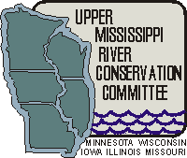

UMRCC 76th Annual Meeting will be held at the Best Western in Dubuque Iowa from March 16 to March 20, 2020. We will begin the registration process this fall.
Here is the hotel contact info: Best Western Plus Dubuque Hotel 3100 Dodge Street Dubuque IA 52003 PHONE: (563) 557-8000 FAX: (563) 557-7692 WEB: www.dbqhotel.com

For those needing early agenda's...
March 16, 2020 Mussel Conservation Team Meeting 12 pm to 5 pm
March 17, 2020 Mussel Tech in AM, Wildlife, LE and WQ and OREIT in PM.
March 17, 2020 Social at National River Museum and Aquarium
March 18, 2020 General UMRCC session all day. Banquet in evening.
March 19, 2020 General UMRCC session in AM followed by Business meeting

